**Ensure uptime:**

STEP-1: STOP ON FAIL

Docker considers any containers to exit with a non-zero exit code to have crashed. By default a crashed container will remain stopped.

Example:

We've created a special container which outputs a message and then exits with code 1 to simulate a crash.

You can launch an instance using docker run -d --name restart-default scrapbook/docker-restart-example

If you list all the containers, including stopped, you will see the container has crashed docker ps -a

While the logs will output our message, which in real-life would hopefully indicate information to help us diagnose the issue.

docker logs restart-default

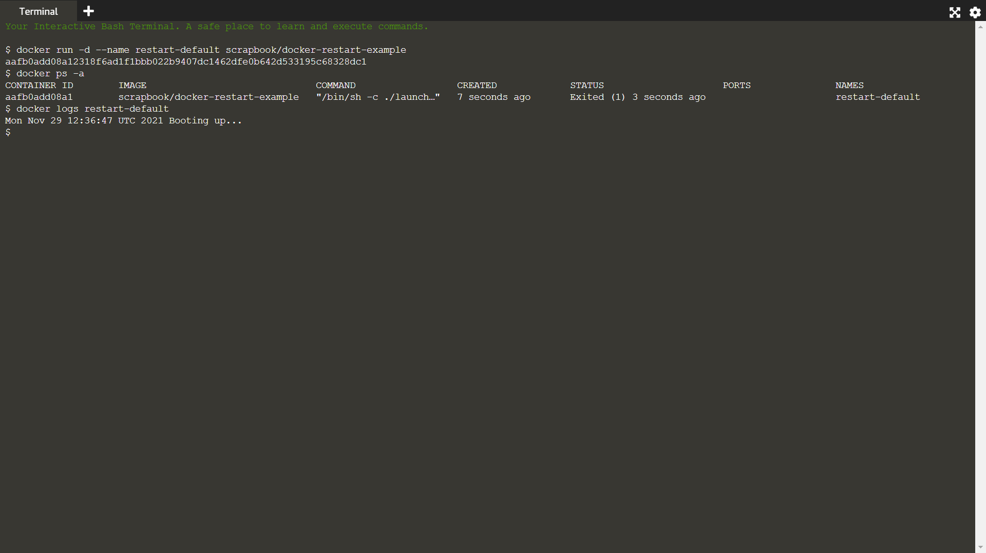

STEP-2: RESTART ON FAIL

Depending on your scenario, restarting a failed process might correct the problem. Docker can automatically retry to launch the Docker a specific number of times before it stops trying

Example:

The option --restart=on-failure:# allows you to say how many times Docker should try again. In the example below, Docker will restart the container three times before stopping.

docker run -d --name restart-3 --restart=on-failure:3 scrapbook/docker-restart-example

As we can see from the logs, it was launched on three occasions.

docker logs restart-3

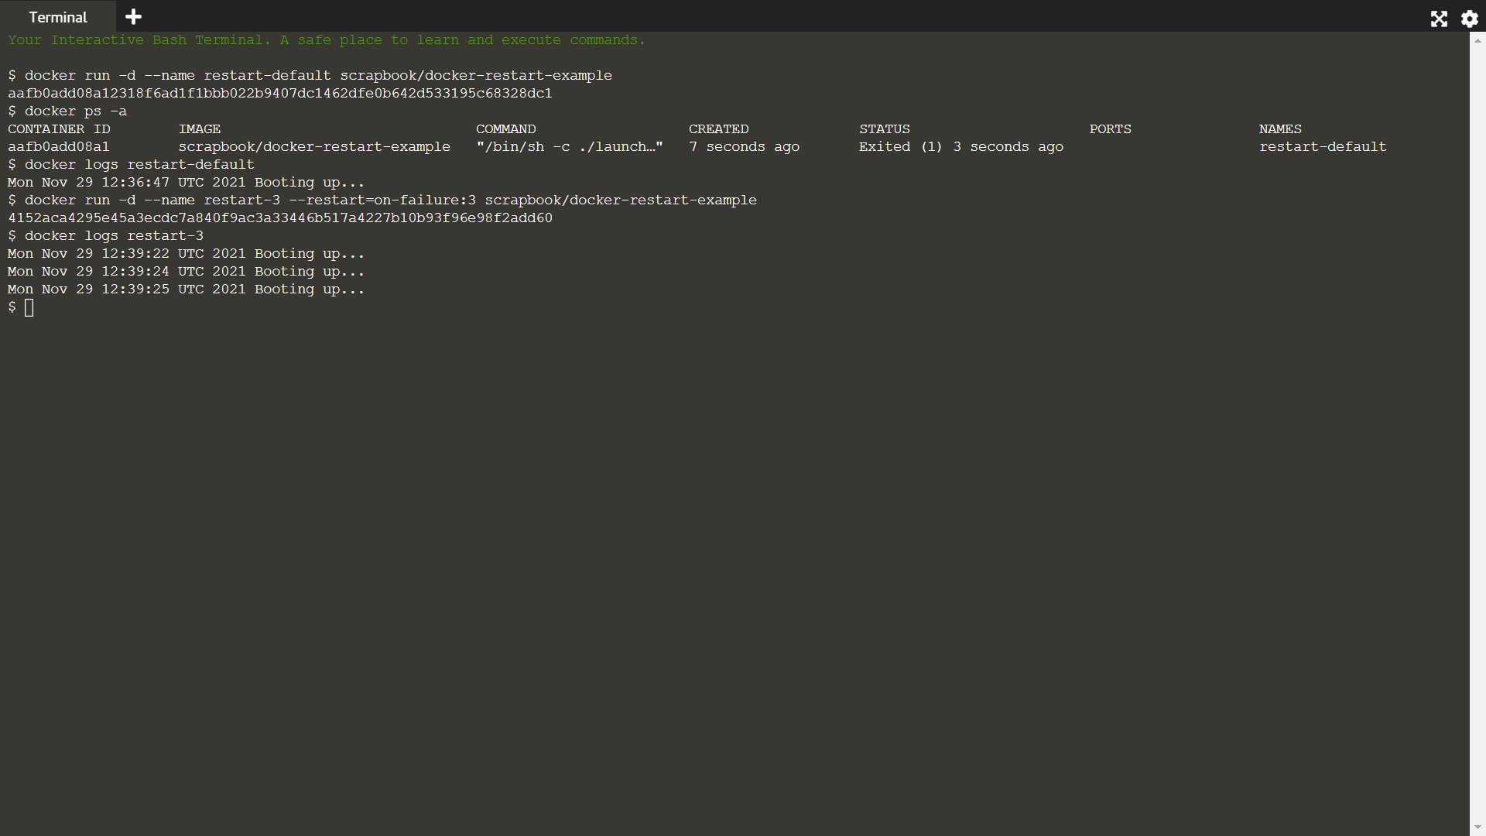

STEP-3: ALWAYS RESTART

Finally Docker can always restart a failed container, in this case, Docker will keep trying until the container it is explicitly told to stop.

Example:

Use the always flag to automatically restart the container when is crashes for example docker run -d --name restart-always --restart=always scrapbook/docker-restart-example

You can view the restart attempting via the log docker logs restart-always

